**GROUP-8**

**POPULAR DIAGONSITC MANAGEMENT SYSTEMS**

**MEMBERS INFROMATION:**

* UL ASIF, MD FARHAN ID: 20-43522-1
* ROY, MRIDUL KUMAR ID: 20-43517-1
* CHAKRABORTY, SUMIT ID: 20-43472-1
* RAFSAN, GAZI SAYDUZZAMAN ID: 20-42066-1

**CASE STUDY**

0ur Popular Diagnostic Management System helps in registering information about Doctors, Patients, Nurse, Employees, Receptionist and others. A unique id is generated for each patient after registration. Their name, age, phone, address, gender and Date of birth are also registered for implementing customer relationship management and maintains medical history of patient. Patients and doctor’s relation are connected through treatment. For this system, we generate a unique id for each doctor. For making the system well managed, we store Doctors id, Doctors name, phone, mail, qualification, department and address. Our nurses assist our doctors. For our nurse, we separately store their name, mail, phone, id, address and for our employees we store their name, post, phone, id, department. It also deals with Receptionist which store Receptionists id, patient arrival date, admit patients, generate doctor’s appointment, patients discharging date and billing the patient. Receptions are connected with patients through the relation subsistence. Receptions are also supervised by Employee section.

**ER-DIAGRAM**

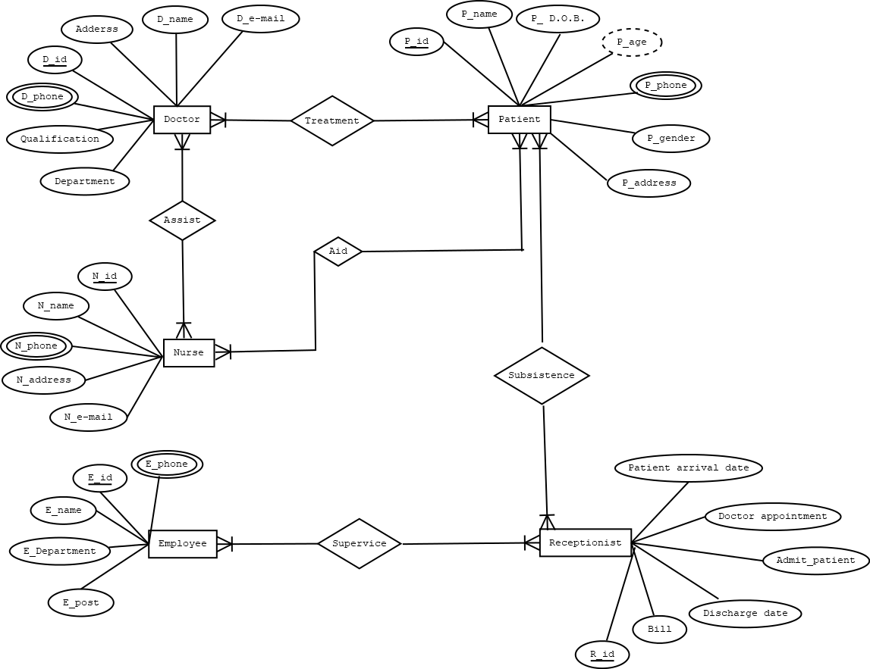

**NORMALIGATION**

**Treatment** (D_id, address, D_name, D_e-mail, qualification, D_phone, Department, P_id, P_name, P_D.O.B, P_age, P_phone, P_gender, P_address)

**1 NF:**

Phone multivalued attribute.

**2 NF:**

D_id, address, D_name, D_e-mail, qualification, D_phone, Department

P_id, P_name, P_D.O.B, P_age, P_phone, P_gender, P_address

DP_id, D_id, P_id

**3 NF:**

D_id, address, D_name, D_e-mail, qualification, D_phone, Department

P_id, P_name, P_phone, P_gender, P_address , IDA

DP_id, D_id, P_id

IDA, P_D.O.B, P_age

**Table:**

D_id, address, D_name, D_e-mail, qualification, D_phone, Department

P_id, P_name, P_phone, P_gender, P_address , IDA

DP_id, D_id, P_id

IDA, P_DOB, P_age

**Assist** (D_id, address, D_name, D_e-mail, qualification, D_phone, Department, N_id, N_name, N_phone, N_address, N_e-mail)

**1 NF:**

Phone multivalued attribute.

**2 NF:**

D_id, address, D_name, D_e-mail, qualification, D_phone, Department

N_id, N_name, N_phone, N_address, N_e-mail

DN_id, D_id, N_id

**3 NF:**

D_id, address, D_name, D_e-mail, qualification, D_phone, Department

N_id, N_name, N_phone, N_address, N_e-mail

DN_id, D_id, N_id

No transitive dependency.

**Table:**

D_id, address, D_name, D_e-mail, qualification, D_phone, Department

N_id, N_name, N_phone, N_address, N_e-mail

DN_id, D_id, N_id

**Aid** (N_id, N_name, N_phone, N_address, N_e-mail, P_id, P_name, P_D.O.B, P_age, P_phone, P_gender, P_address )

**1 NF:**

Phone multivalued attribute.

**2 NF:**

N_id, N_name, N_phone, N_address, N_e-mail

P_id, P_name, P_D.O.B, P_age, P_phone, P_gender, P_address

NP_id, N_id, P_id

**3 NF:**

N_id, N_name, N_phone, N_address, N_e-mail

P_id, P_name, P_phone, P_gender, P_address, IDA

NP_id, N_id, P_id

IDA, P_D.O.B, P_age

**Table:**

N_id, N_name, N_phone, N_address, N_e-mail

P_id, P_name, P_phone, P_gender, P_address, IDA

NP_id, N_id, P_id

IDA, P_D.O.B, P_age

**Subsistence** (P_id, P_name, P_D.O.B, P_age, P_phone, P_gender, P_address, R_id, Bill, Discharge date, Admit_patient, Doctor appointment, Patient arrival date)

**1 NF:**

Phone multivalued attribute.

**2 NF:**

P_id, P_name, P_D.O.B, P_age, P_phone, P_gender, P_address

R_id, Bill, Discharge date, Admit_patient, Doctor appointment, Patient arrival date

PR_id, P_id, R_id

**3 NF**:

P_id, P_name, P_phone, P_gender, P_address, IDA

R_id, Bill, Discharge date, Admit_patient, Doctor appointment, Patient arrival date

PR_id, P_id, R_id

IDA, P_D.O.B, P_age

**Table:**

P_id, P_name, , P_phone, P_gender, P_address, IDA

R_id, Bill, Discharge date, Admit_patient, Doctor appointment, Patient arrival date

PR_id, P_id, R_id

IDA, P_D.O.B, P_age

**Supervice** (E_id, E_name, E_phone, E_department, E_post, R_id, Patient arrival date, Doctor appointment, Admit_patient, Discharge_date, Bill)

**1 NF:**

Phone multivalued attribute.

**2 NF:**

E_id, E_name, E_phone, E_department, E_post

R_id, Patient arrival date, Doctor appointment, Admit_patient, Discharge_date, Bill

ER_id, E_id, R_id

**3 NF**:

E_id, E_name, E_phone, E_department, E_post

R_id, Patient arrival date, Doctor appointment, Admit_patient, Discharge_date, Bill

ER_id, E_id, R_id

No transitive dependency.

**Table:**

E_id, E_name, E_phone, E_department, E_post

R_id, Patient arrival date, Doctor appointment, Admit_patient, Discharge_date, Bill

ER_id, E_id, R_id

**Total table:**

~~D_id, address, D_name, D_e-mail, qualification, D_phone, Department~~

~~P_id, P_name, P_phone, P_gender, P_address , IDA~~

DP_id, D_id, P_id

~~IDA, P_DOB, P_age~~

D_id, address, D_name, D_e-mail, qualification, D_phone, Department

~~N_id, N_name, N_phone, N_address, N_e-mail~~

DN_id, D_id, N_id

N_id, N_name, N_phone, N_address, N_e-mail

~~P_id, P_name, P_phone, P_gender, P_address, IDA~~

NP_id, N_id, P_id

~~IDA, P_D.O.B, P_age~~

P_id, P_name, , P_phone, P_gender, P_address, IDA

~~R_id, Bill, Discharge date, Admit_patient, Doctor appointment, Patient arrival date~~

PR_id, P_id, R_id

IDA, P_D.O.B, P_age

E_id, E_name, E_phone, E_department, E_post

R_id, Patient arrival date, Doctor appointment, Admit_patient, Discharge_date, Bill

ER_id, E_id, R_id

**Final table:**

DP_id, D_id, P_id : DOCTOR_PATIENT_ID_INFO

D_id, Address, D_name, D_e-mail, qualification, D_phone, Department: DOCTOR _INFO

DN_id, D_id, N_id : ASSIST_ID_INFO

N_id, N_name, N_phone, N_address, N_e-mail : NURSE_INFO

NP_id, N_id, P_id : AID_ID_INFO

P_id, P_name, P_phone, P_gender, P_address, IDA : NURSE_INFO

PR_id, P_id, R_id : SUBSISTENCE_ID_INFO

IDA, P_D.O.B, P_age : PATIENT_ADDITAONAL_INFO

E_id, E_name, E_phone, E_department, E_post : EMPLOYEE_INFO

R_id, Patient arrival date, Doctor appointment, Admit_patient, Discharge_date, Bill: RECEPTIONIST_INFO

ER_id, E_id, R_id: SUPERVICE_ID_INFO

**TABLE CREATION AND DATA INSERTATION**

**TABLE CREATION:** DOCTOR_INFO

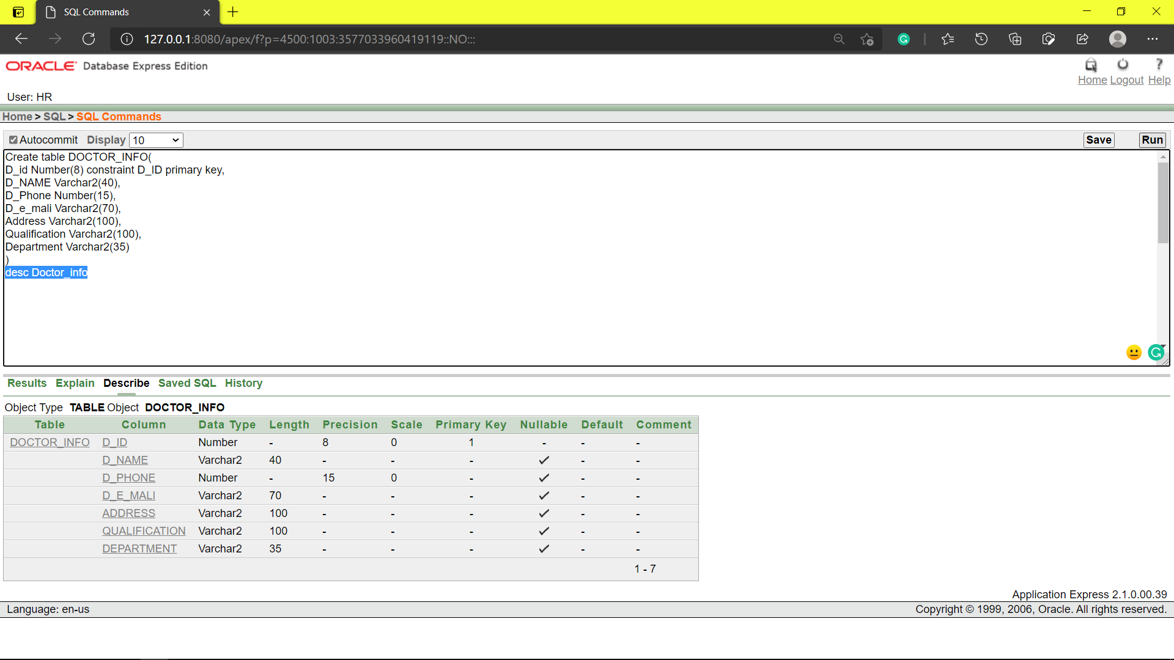

**TABLE INSERTATION:** DOCTOR_INFO

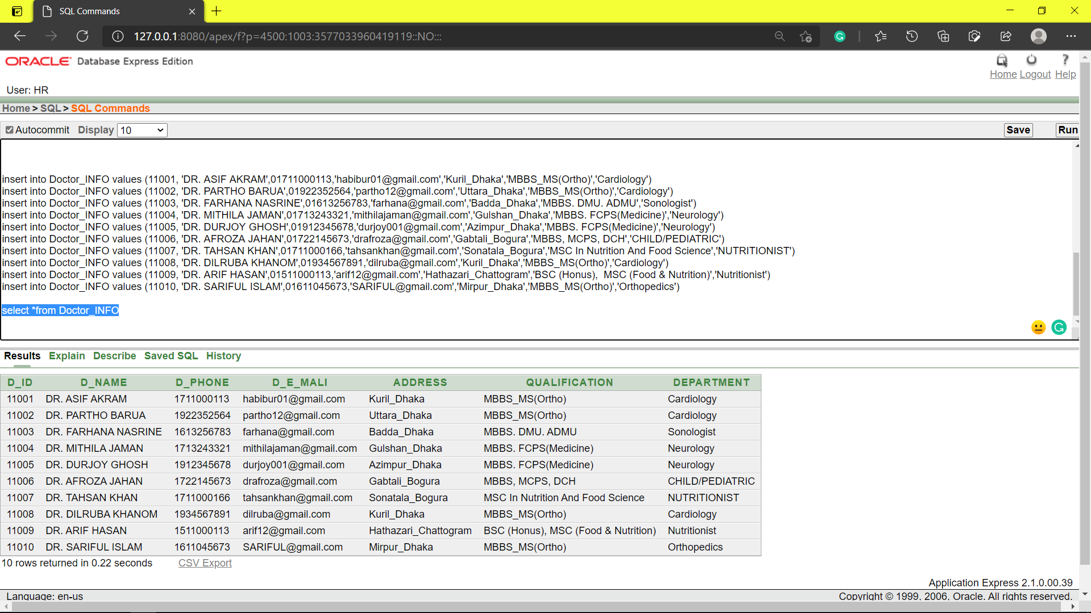

**TABLE CREATION:** NURSE_INFO

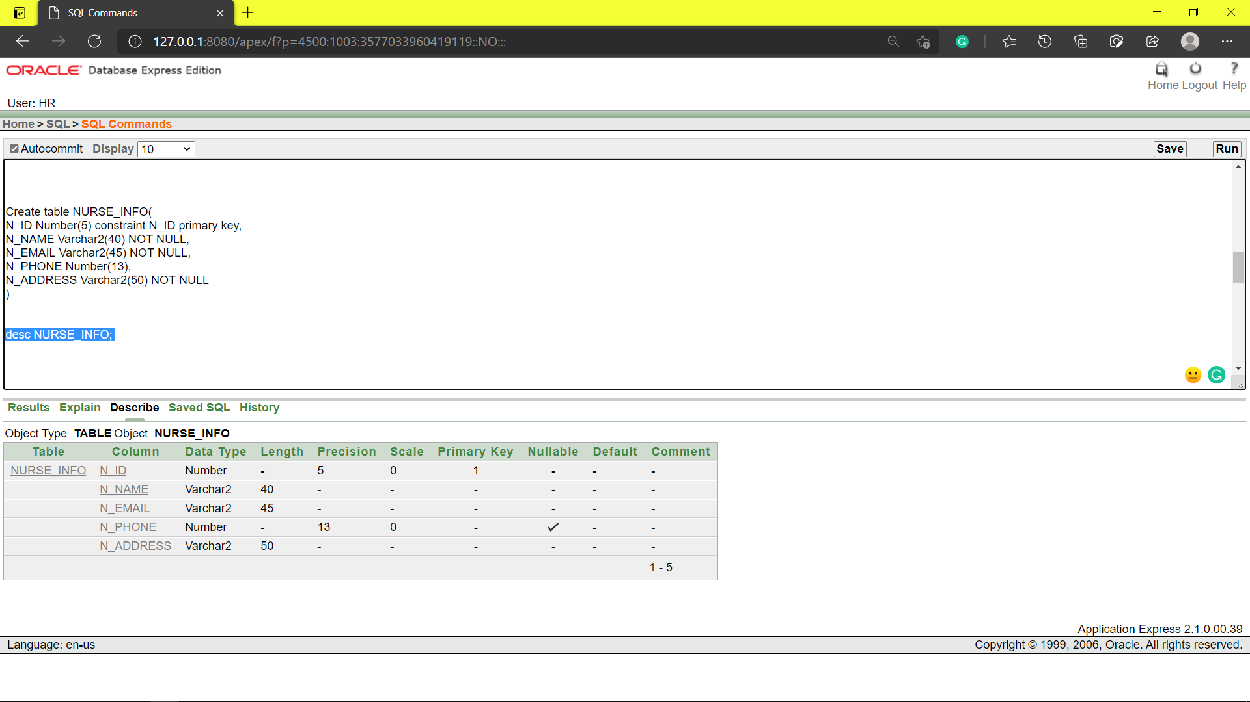

**TABLE INSERTATION:** NURSE_INFO

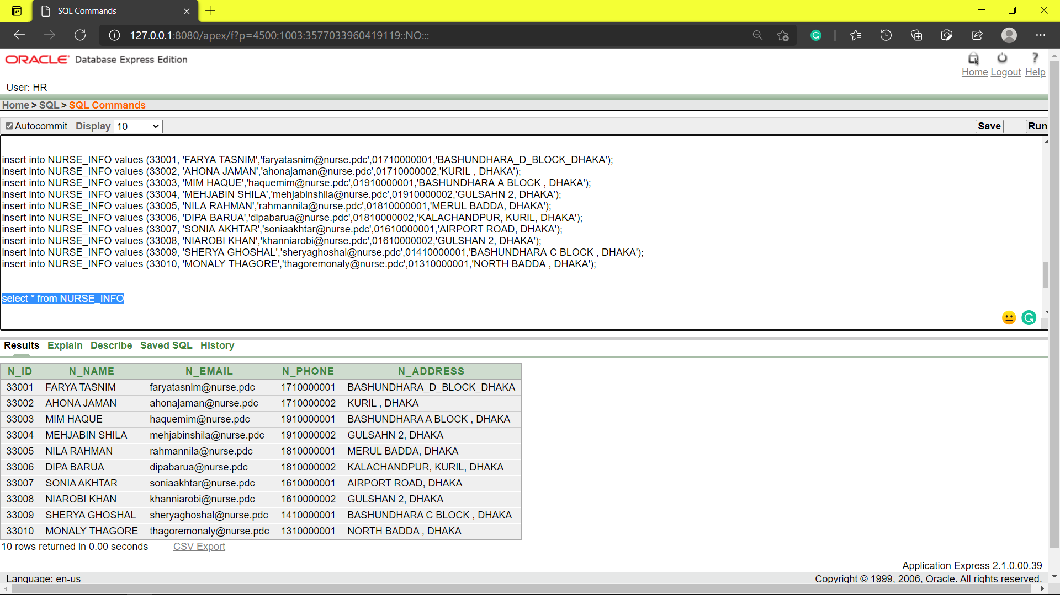

**TABLE CREATION:** EMPLOYEE_INFO

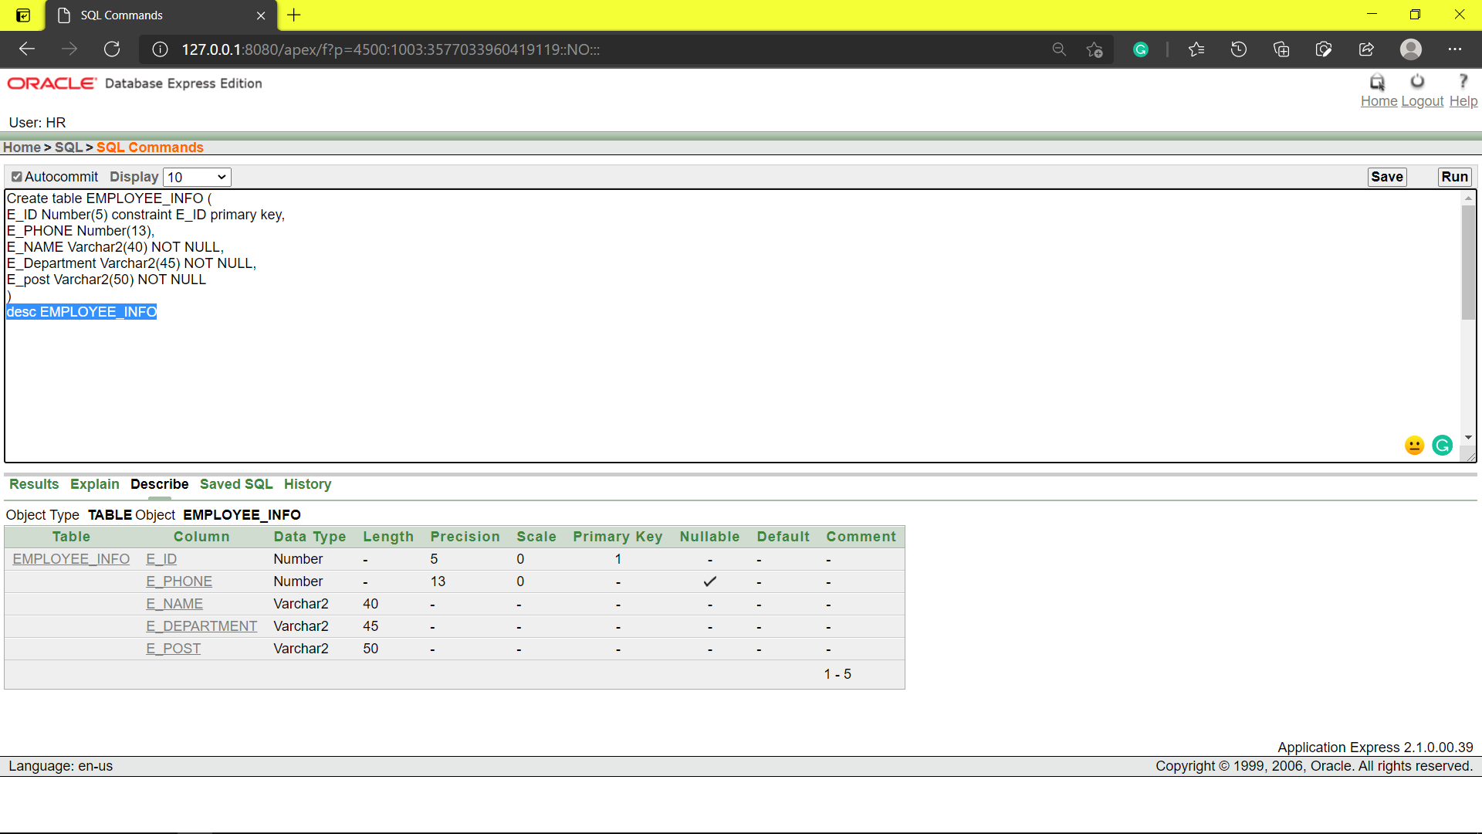

**TABLE INSERTATION:** EMPLOYEE_INFO

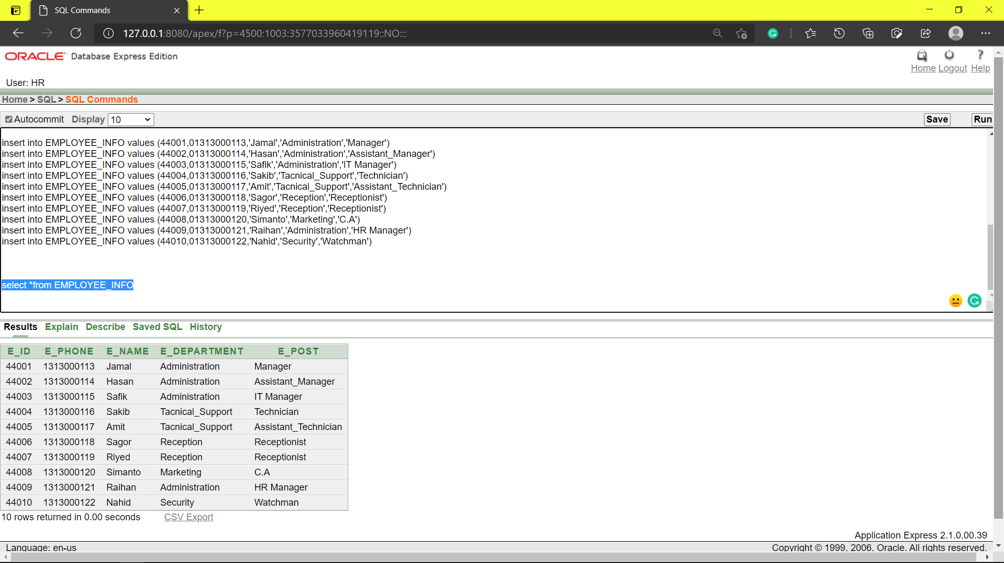

**TABLE CREATION:** PATIENT_INFO

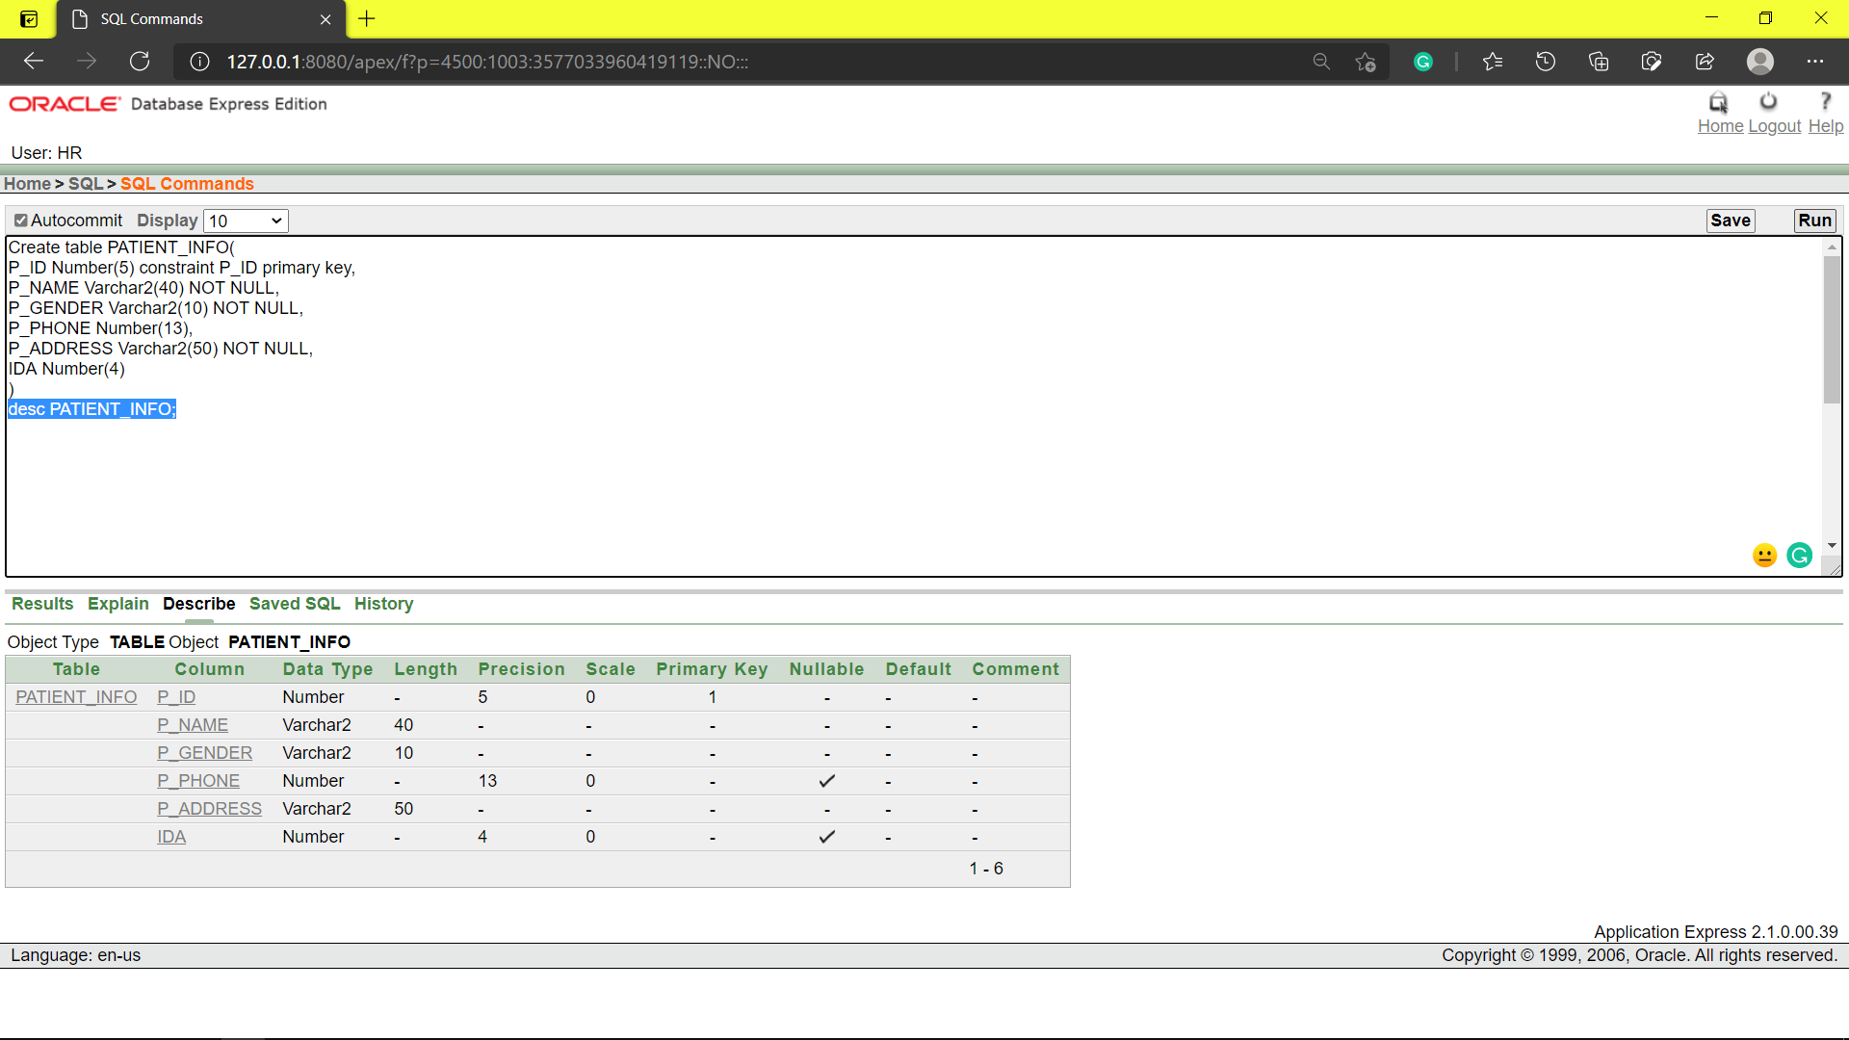

**TABLE INSERTATION:** PATIENT_INFO

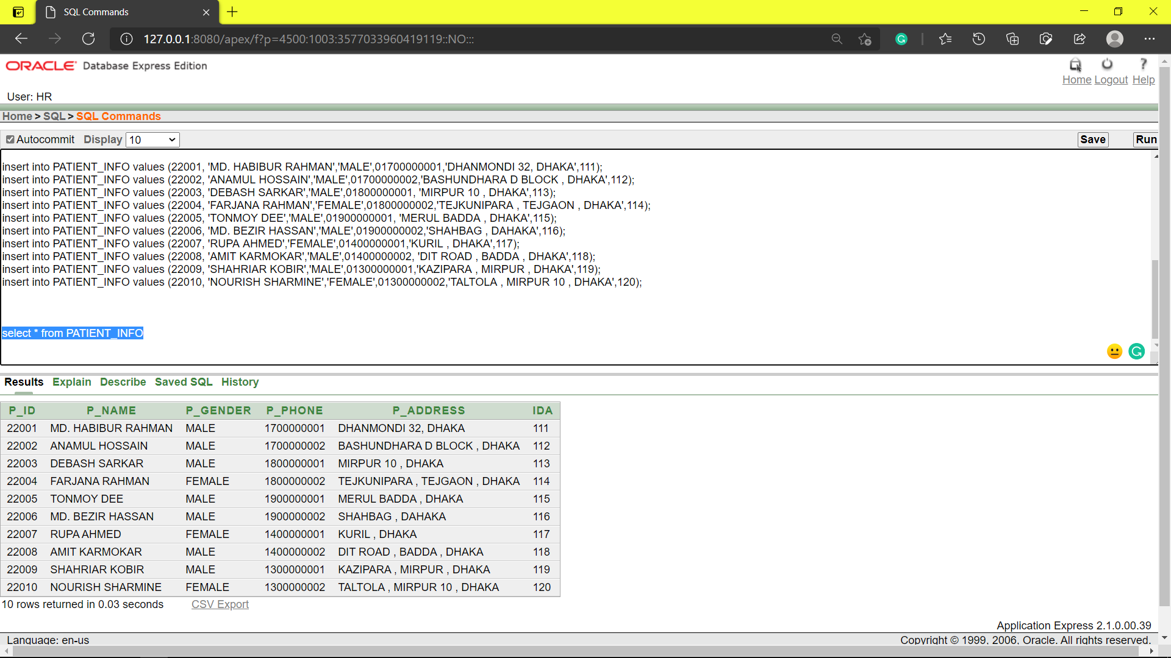

**TABLE CREATION:** PATIENT_ADDITIONAL_INFO

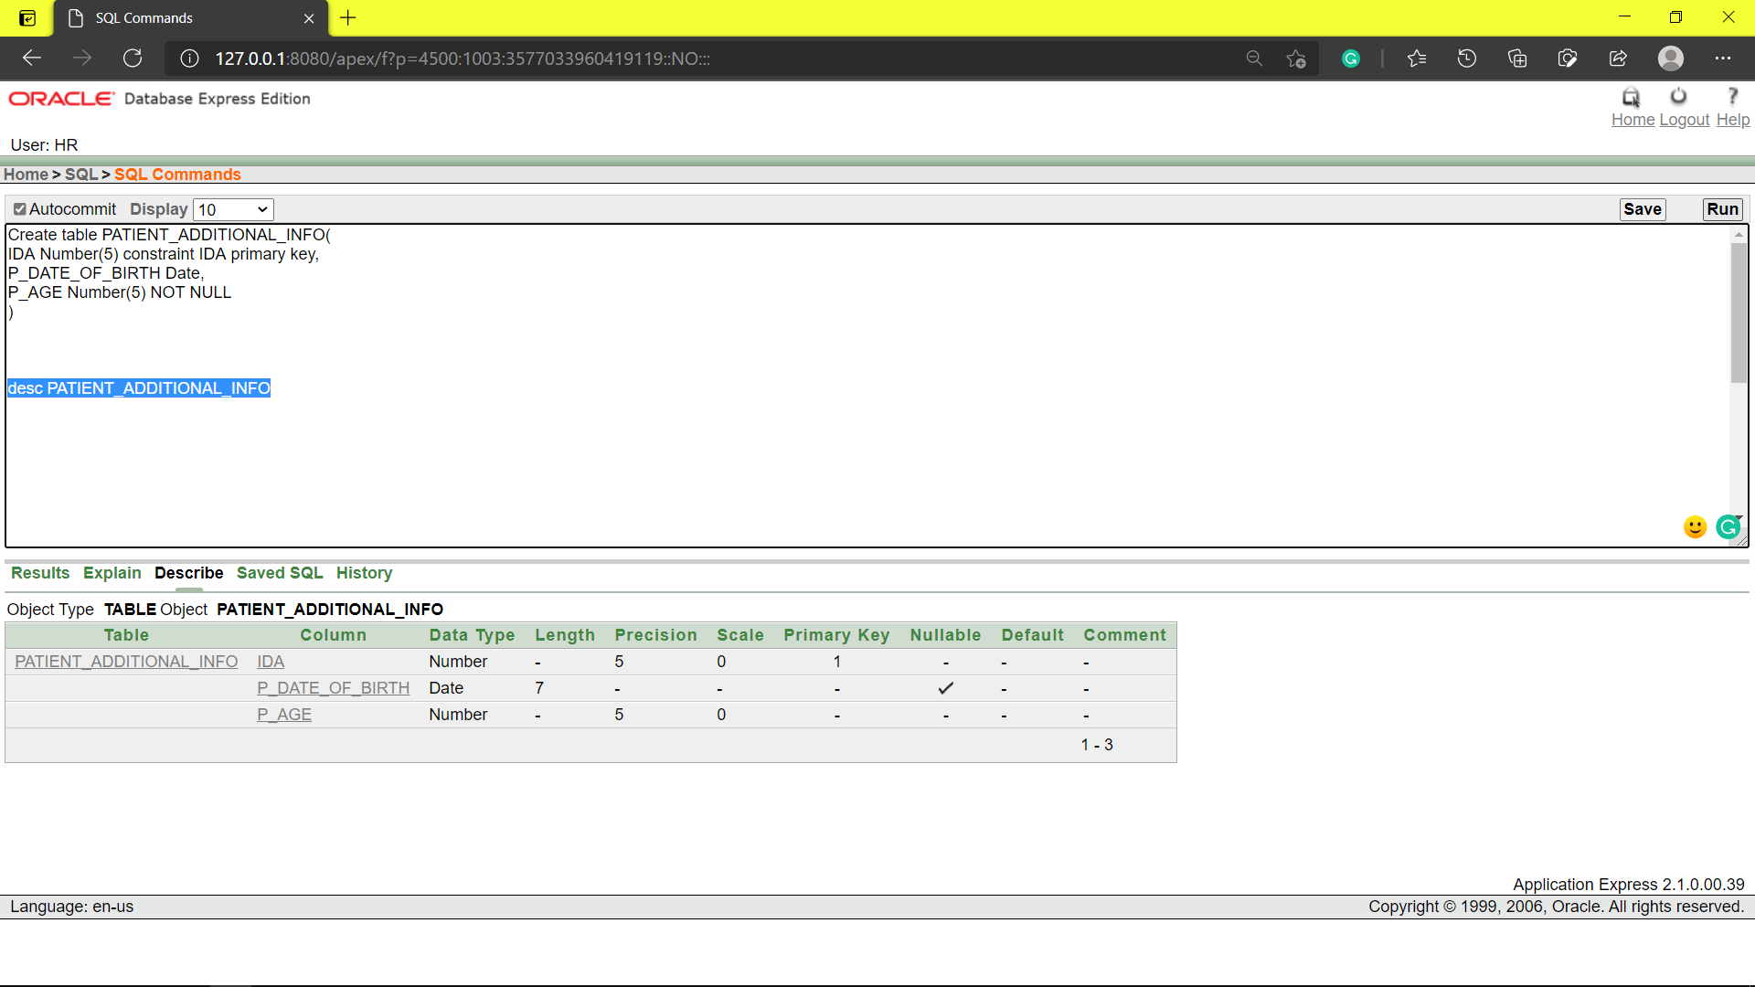

**TABLE INSERTATION:** PATIENT_ADDITIONAL_INFO

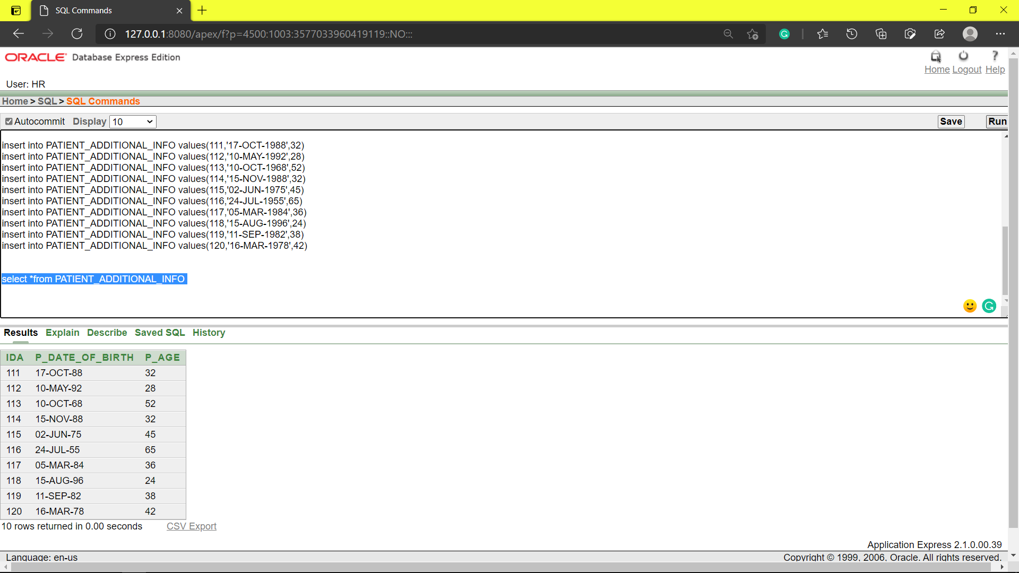

**TABLE CREATION:** RECEPTIONST_INFO

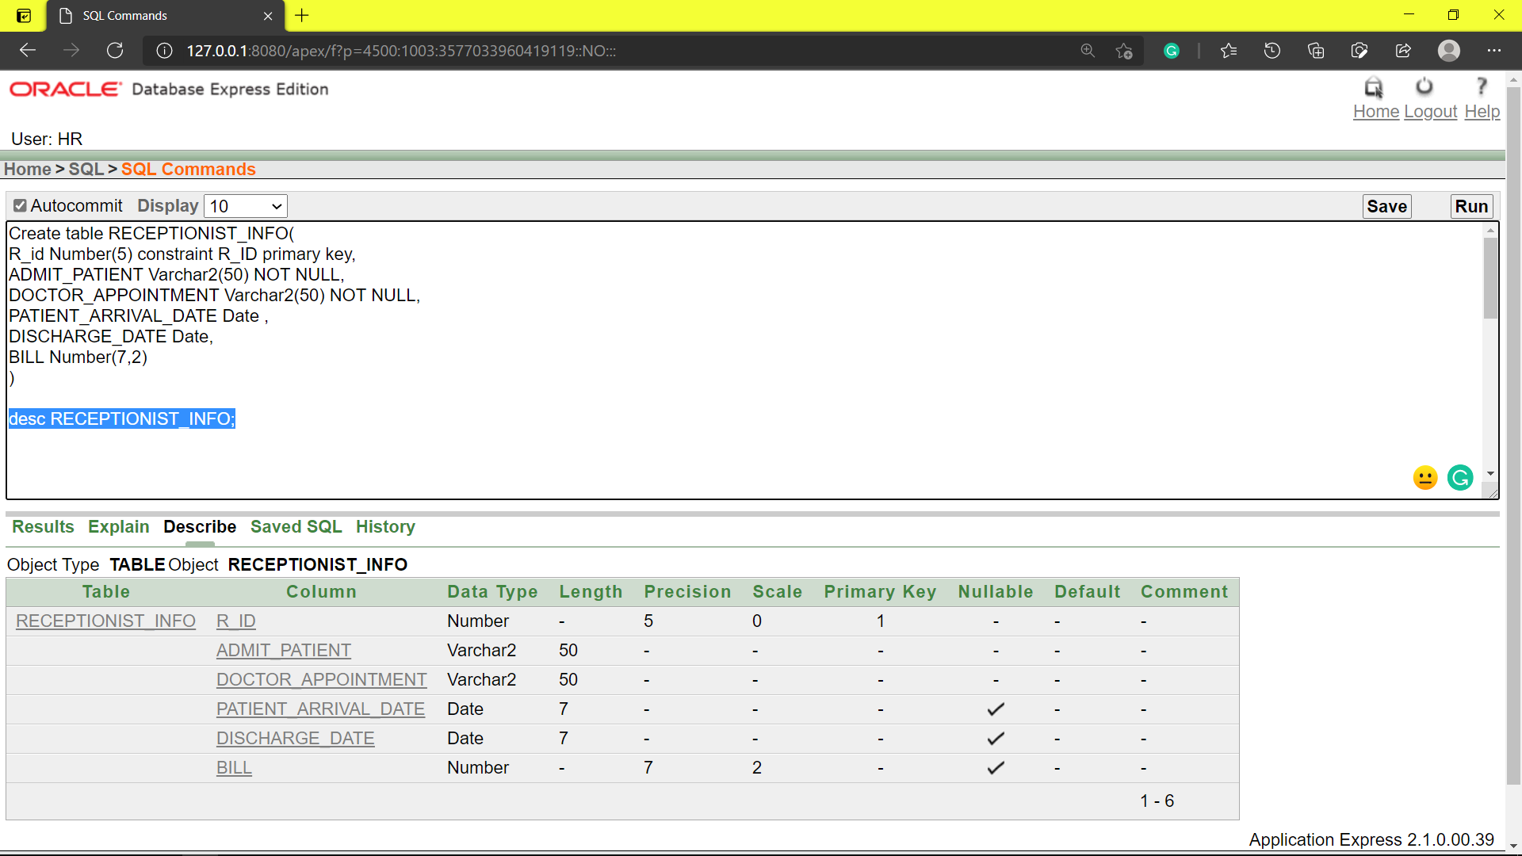

**TABLE INSERTATION:** RECEPTIONST_INFO

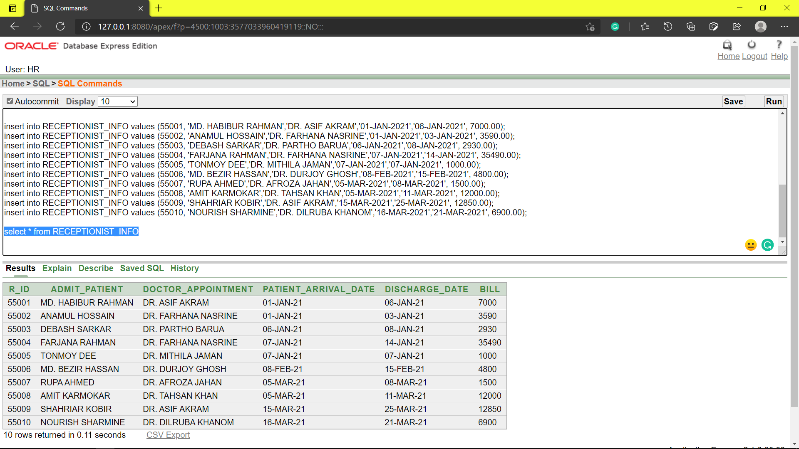

**TABLE CREATION:** DOCTOR_PATIENT_ID_INFO

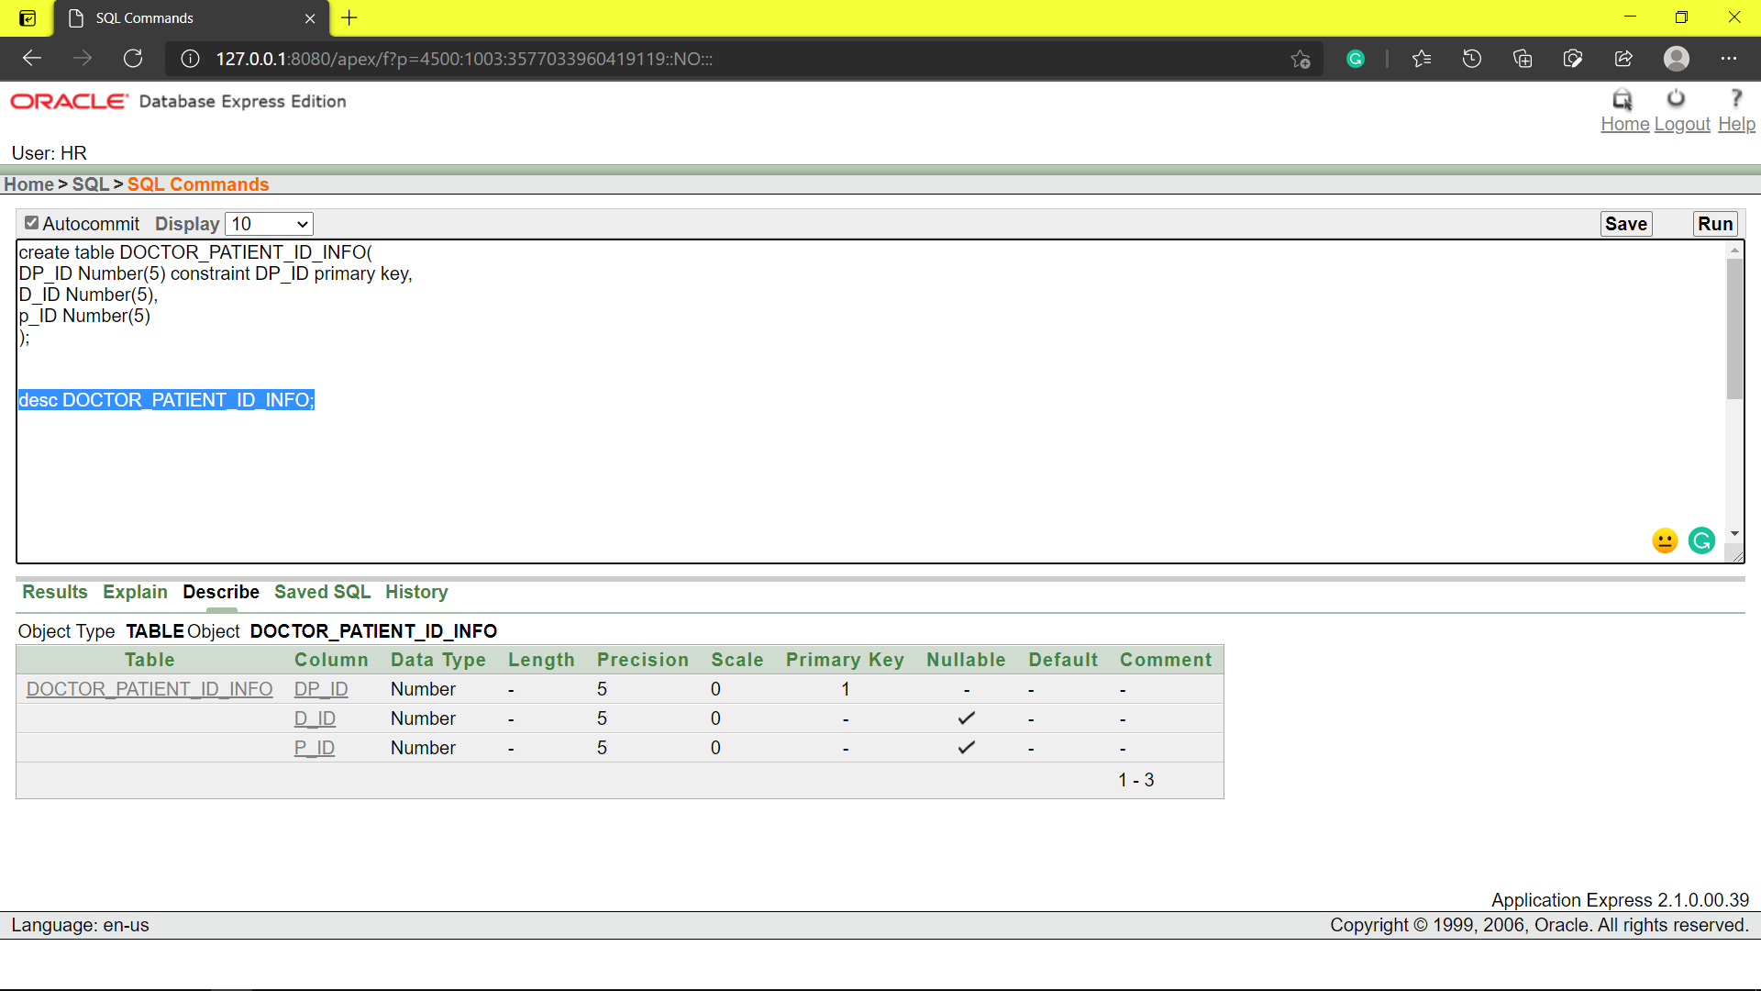

**TABLE INSERTATION:** DOCTOR_PATIENT_ID_INFO

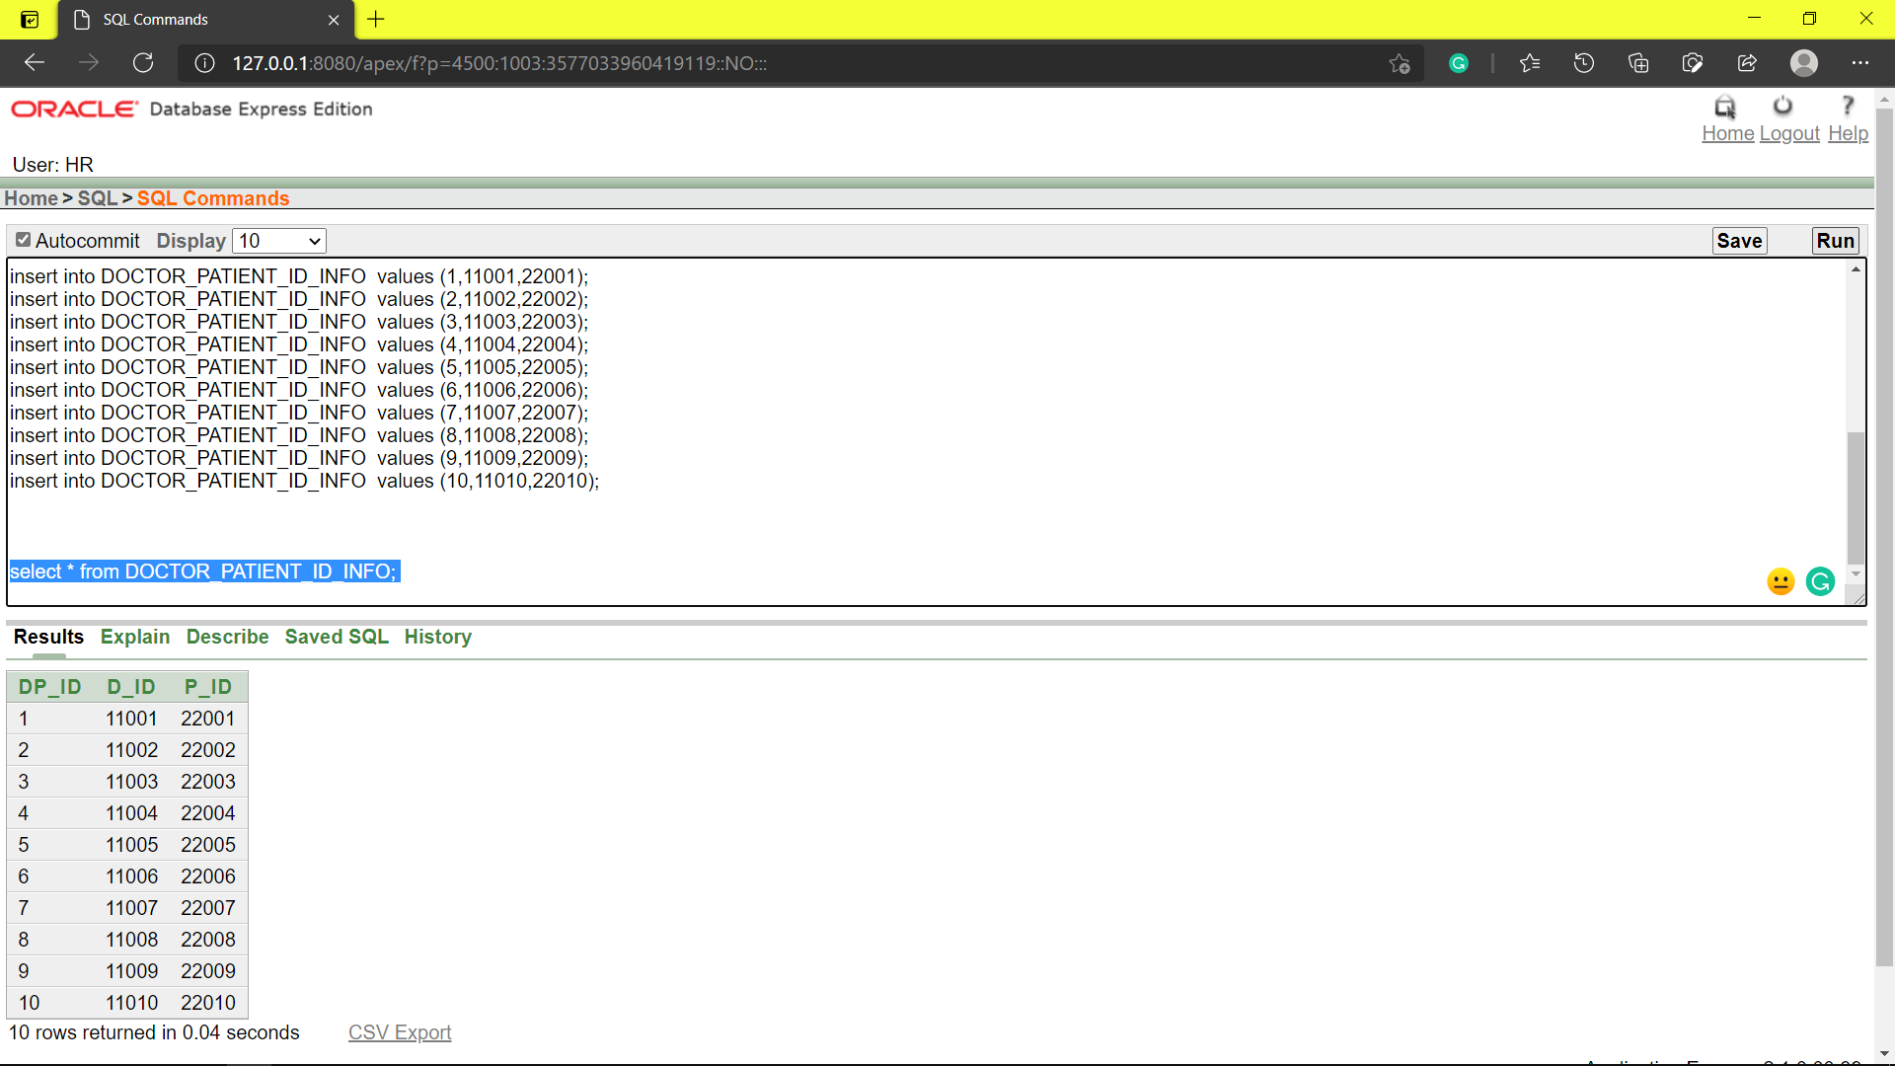

**TABLE CREATION:** SUBSISTENCE_ID_INFO

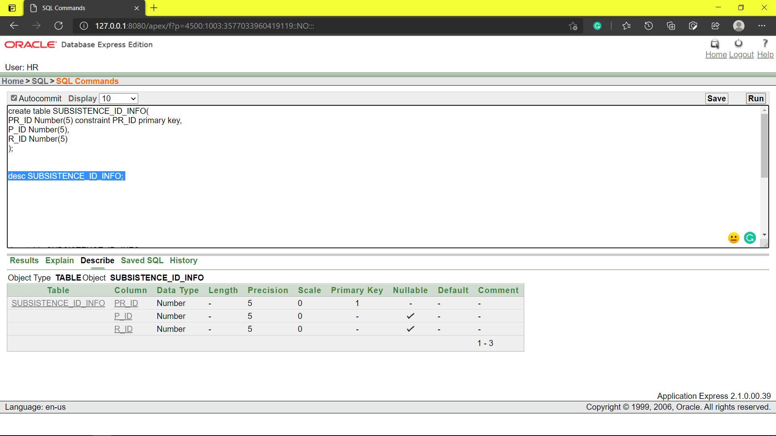

**TABLE INSERTATION:** SUBSISTENCE_ID_INFO

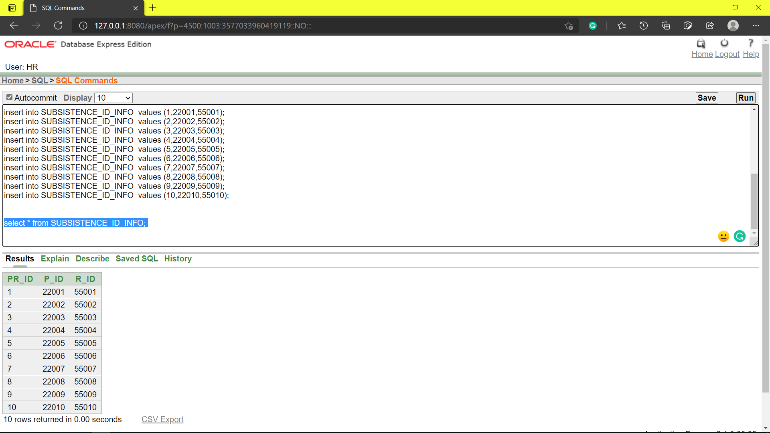

**TABLE CREATION**: SUPERVICE_ID_INFO

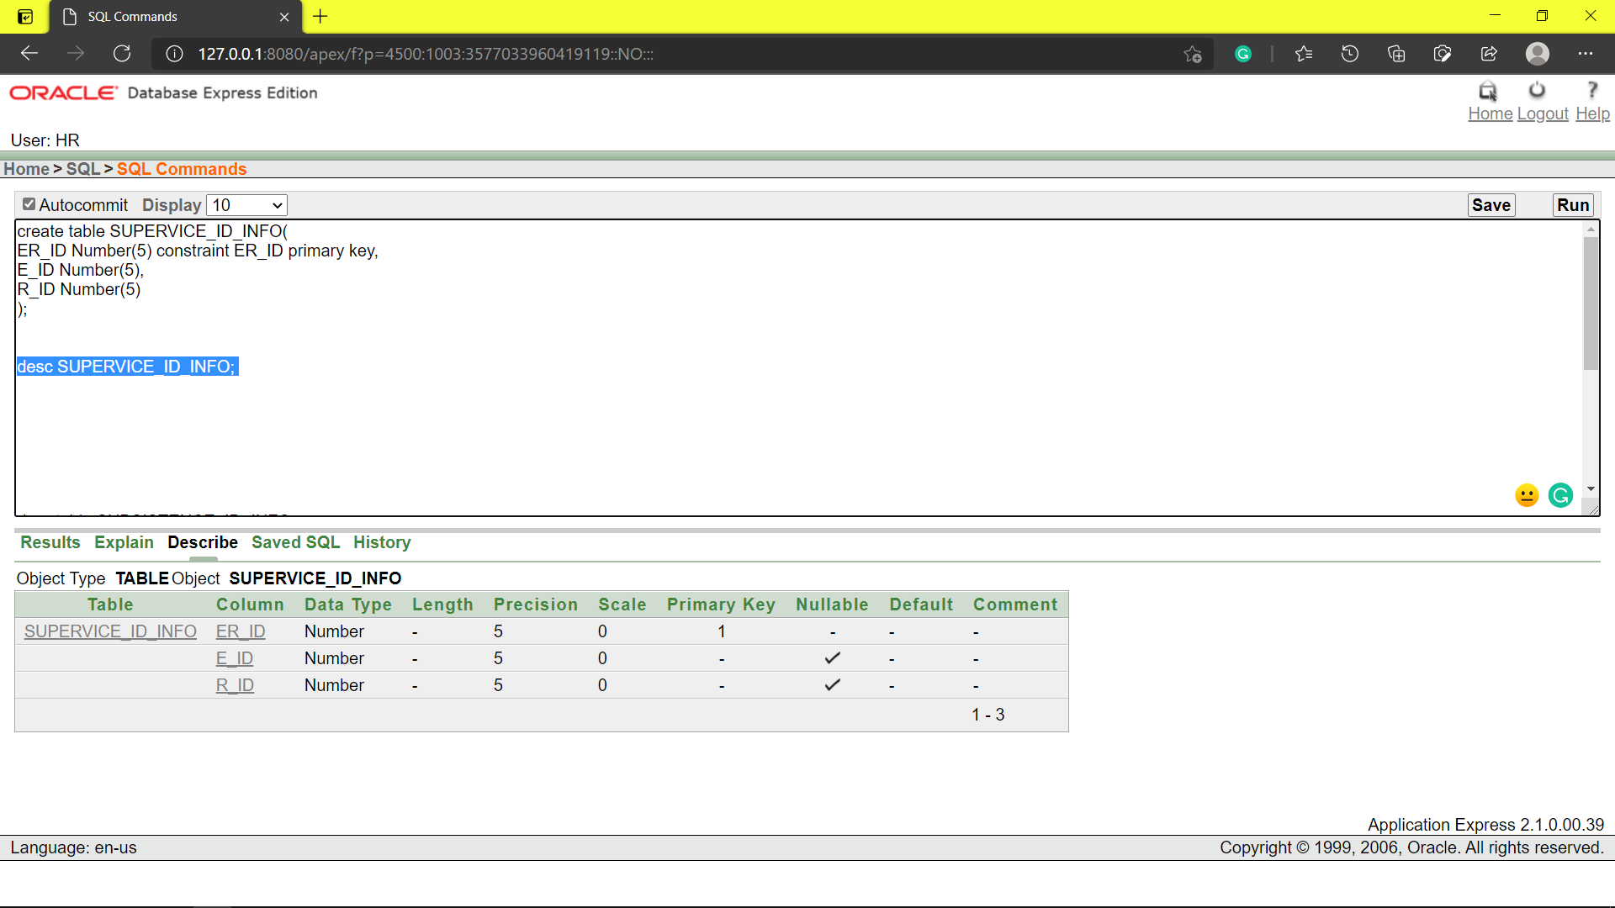

**TABLE INSERTATION**: SUPERVICE_ID_INFO

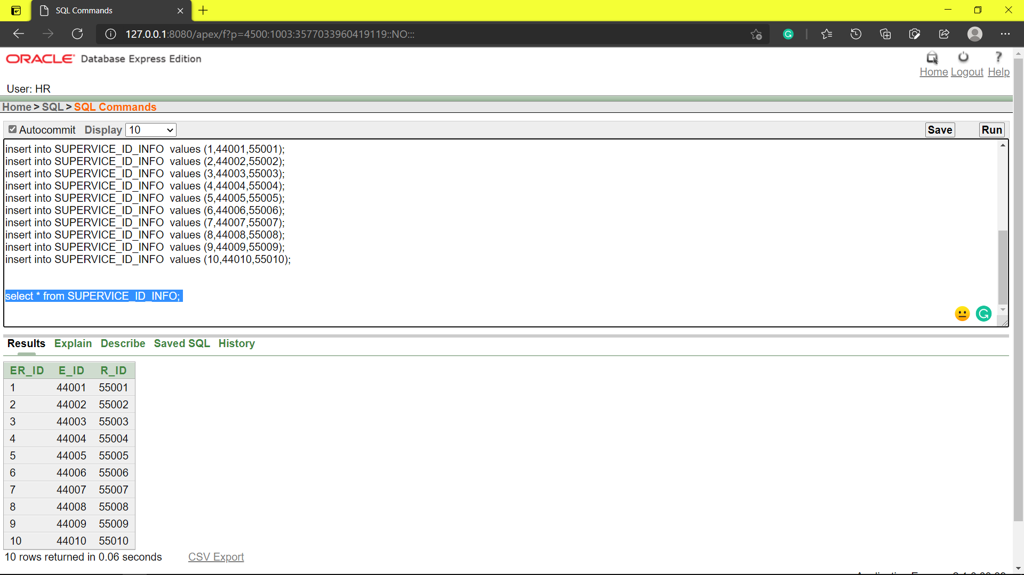

**TABLE CREATION**: ASSIST_ID_INFO

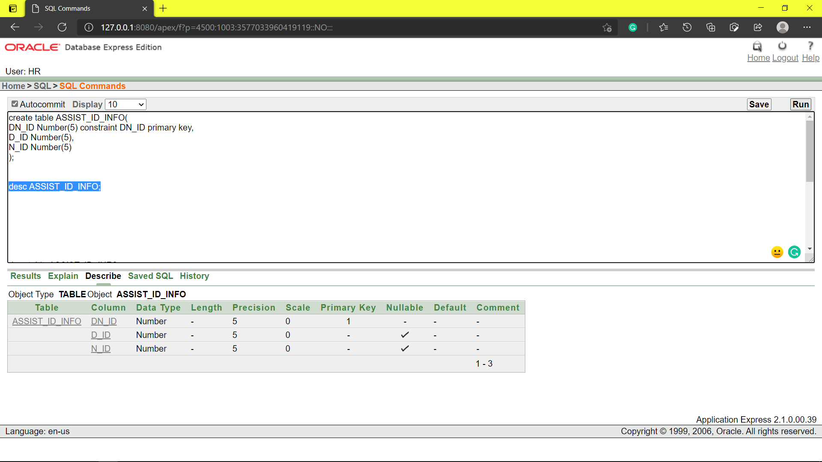

**TABLE INSERTATION**: ASSIST_ID_INFO

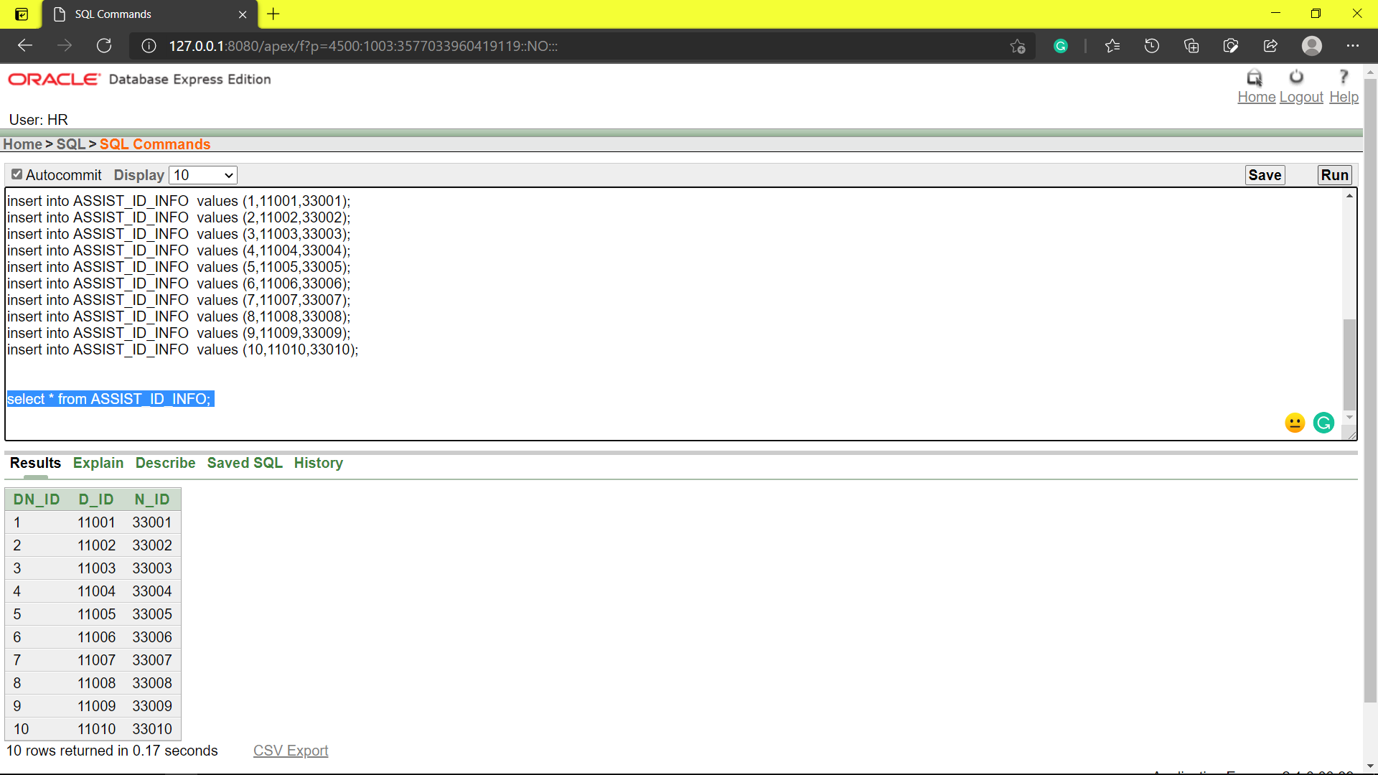

**TABLE CREATION**: AID_ID_INFO

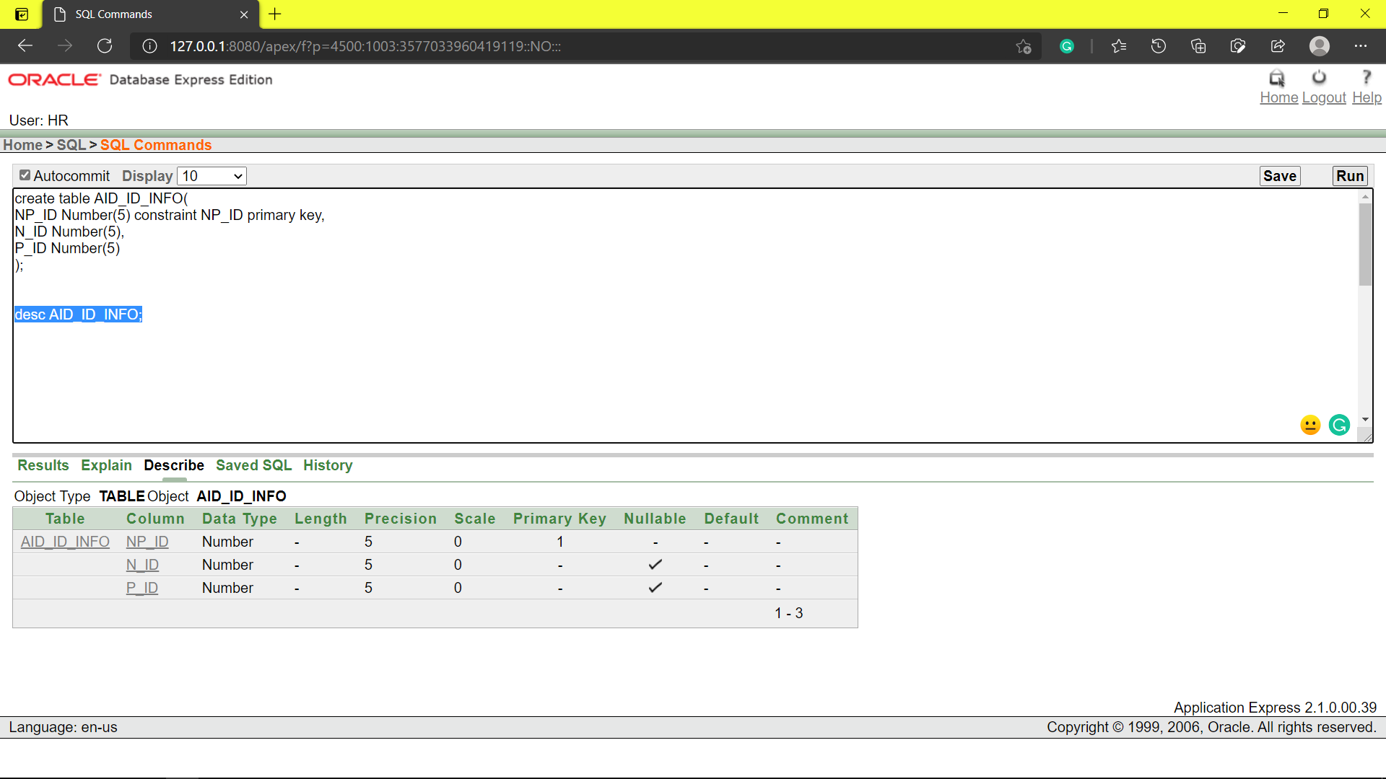

**TABLE INSERTATION**: AID_ID_INFO

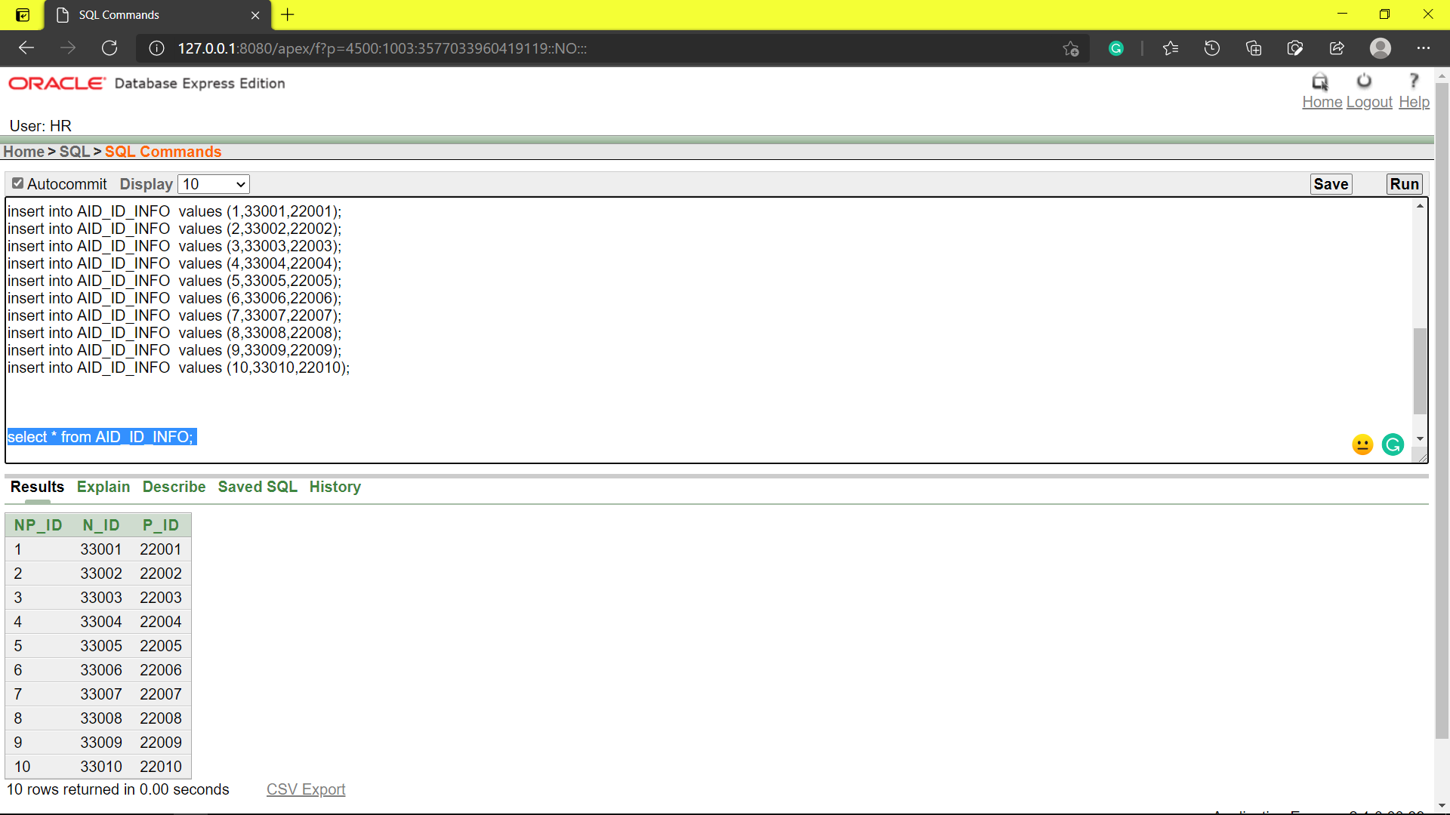

**Queries**

**JOINING**

1. Display receptionist Id, admit patient, patient name where patient arrival date is before ‘8-FEB-2021’ and patient gender is male. Use the RECEPTIONIST_INFO and PATIENT_INFO table
2. Find out Employee Id, Employee name, Employee post where employee department is administration. Use the EMPLOYEE_INFO table.
3. Display patient id, patient name, doctor address where patient age is more than 32 and doctor department is ‘Neurology’. Use the PATIENT_INFO, PATIENT_ADDITIONAL_INFO and DOCTOR_INFO table.

**SUB-QUERY**

1. Display any doctor_name from DOCTOR_INFO whose department is same as Dr.Partho Barua
2. List all the PATIENT P_Name and P_PHONE whose age is more than Anamul Hossain or less than Debash Sarkar . Also arrange age from high to low.
3. Find all the PATIENT_INFO(P_ID) and P_GENDER who are senior than TONMOY DEE

**VIEW**

1. Create a view that shows branch information P_NAME, P_AGE, P_DATE_OF_BIRTH